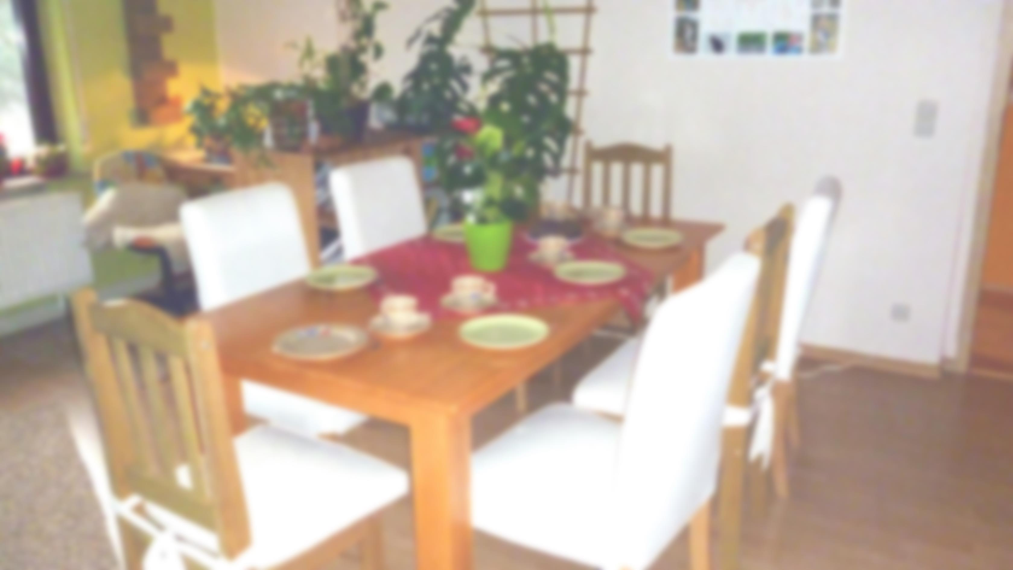Birthdays

|  |  |  |  |  |  |
| --- | --- | --- | --- | --- | --- |
| January | February | March | April | May | June |
| __________ | __________ | __________ | __________ | __________ | __________ |
| __________ | __________ | __________ | __________ | __________ | __________ |
| __________ | __________ | __________ | __________ | __________ | __________ |
| __________ | __________ | __________ | __________ | __________ | __________ |
| __________ | __________ | __________ | __________ | __________ | __________ |
| __________ | __________ | __________ | __________ | __________ | __________ |
| __________ | __________ | __________ | __________ | __________ | __________ |
|  |  |  |  |  |  |
| July | August | September | October | November | December |
| __________ | __________ | __________ | __________ | __________ | __________ |
| __________ | __________ | __________ | __________ | __________ | __________ |
| __________ | __________ | __________ | __________ | __________ | __________ |
| __________ | __________ | __________ | __________ | __________ | __________  © 2016 by CK-Pictures. Free download: www.ck-pictures.net |
| __________ | __________ | __________ | __________ | __________ | __________ |
| __________ | __________ | __________ | __________ | __________ | __________ |
| __________ | __________ | __________ | __________ | __________ | __________ |