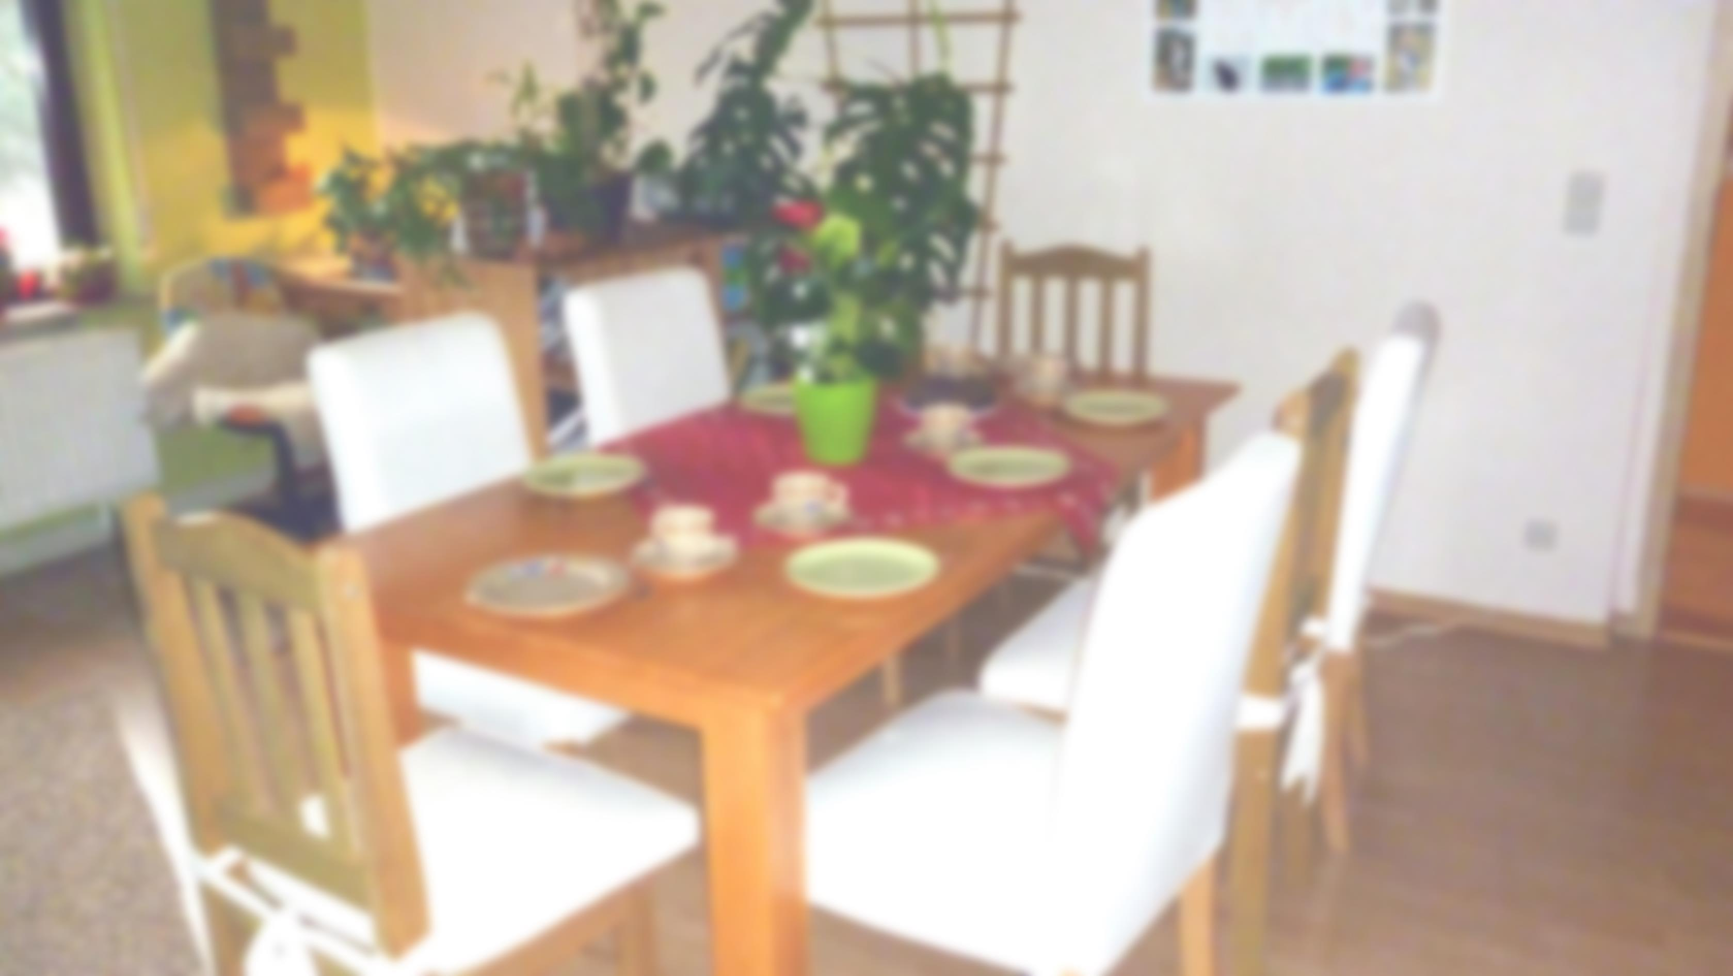Geburtstage

|  |  |  |  |  |  |
| --- | --- | --- | --- | --- | --- |
| Januar | Februar | März | April | Mai | Juni |
| __________ | __________ | __________ | __________ | __________ | __________ |
| __________ | __________ | __________ | __________ | __________ | __________ |
| __________ | __________ | __________ | __________ | __________ | __________ |
| __________ | __________ | __________ | __________ | __________ | __________ |
| __________ | __________ | __________ | __________ | __________ | __________ |
| __________ | __________ | __________ | __________ | __________ | __________ |
| __________ | __________ | __________ | __________ | __________ | __________ |
|  |  |  |  |  |  |
| Juli | August | September | Oktober | November | Dezember |
| __________ | __________ | __________ | __________ | __________ | __________ |
| __________ | __________ | __________ | __________ | __________ | __________ |
| __________ | __________ | __________ | __________ | __________ | __________ |
| __________ | __________ | __________ | __________ | __________ | __________  © 2016 by CK-Pictures. Free download: www.ck-pictures.net |
| __________ | __________ | __________ | __________ | __________ | __________ |
| __________ | __________ | __________ | __________ | __________ | __________ |
| __________ | __________ | __________ | __________ | __________ | __________ |